Red Book Order Form

- 3rd Edition (March 2020)

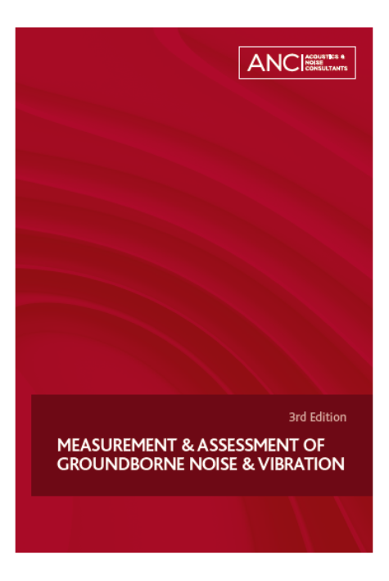 | Measurement & Assessment of Groundborne Noise & Vibration  This essential book provides practical guidelines on the measurement and assessment of groundborne noise and vibration. It has been prepared on behalf of the Association of Noise Consultants by specialists in this field. A wide range of vibration issues and sources is covered with particular attention paid to railway vibration and groundborne noise. This third edition includes a full review of current standards and guidance as well as recent research, and has been expanded to cover a very wide range of topics within its scope.  It provides essential guidance on techniques for measurement, prediction, assessment and mitigation of groundborne noise and vibration in a wide range of circumstances and assistance is given in overcoming many of the problems associated with widely different procedures, criteria and equipment adopted across the industry.

Purchase Price = £95 (ANC Members £70) +£4.00 p&p (£10.00 p&p for Overseas)

Name
Company
Delivery Address
Email
Phone
Number of copies
We would like to notify you if the book is updated or if we arrange an event concerning the book. Please indicate your agreement here:

Payment is required in advance and orders cannot be despatched until it has been received.
Payment method:

- Credit Card: A payment request will be emailed to you.

- Direct to Bank: BACS: Account No: 10501336 Sort Code: 20 91 48
Bank Transfer: IBAN: GB89 BARC 2091 4810 5013 36, SWIFT: BARCGB22
Please quote ‘Red Book Order’ and your name.
- Invoice: Please supply PO number if needed.

Please return this form to info@theanc.co.uk

